**Magical Mama (or Papa)**

Be your kids’ very own Harry Houdini—without the locks, chains and water tanks, of course. Simply place a coin under one of three cups and shuffle the cups around. Then ask your children to guess which cup holds the coin. Sneaky parents can place the cups near the edge of a table and secretly drop the coin. Watch your tots’ eyes light up in amazement when they learn the coin is gone!

CARD GAMES:

Go Fish!

Crazy 8

Memory

Battle

## How can you play a really fun card game and have everyone laughing?

This game can be called "Salute the King"; however, if anyone can think of a better name, I'm open to ideas. It's ideal for 3-8 players of any age, but the group can be larger. Kids and adults alike will enjoy it, guaranteed! It makes a great game to play with friends and family, especially during the holidays!

## How to Play the Game

You will need a deck of cards, and if you are a group over 8, I suggest two decks of cards. Decks can even be missing cards because the only ones that really matter are the ace, king, queen, and jack. You could also probably use a tissue box next to you because you will be laughing so hard.

### Instructions

1. Deal all the cards face down. It is better if everyone has the same amount of cards, but it is not mandatory. You can designate one person to be the dealer and that person will be in charge of giving back the cards from the middle of the table to the losing player in each round.
2. The object of the game is to get rid all your cards. The first person to do that is declared the winner.
3. The game can continue on, though, until you get fed up of playing, have run out of Kleenex, or your stomach begins to hurt from all the laughing!

### What Do the Cards Mean?

Every player must now, one by one, turn over the top card on their pile without looking at it first and place it in the middle of the table. As soon as the first person reveals an ace, king, queen, or jack, here is what EVERYONE in the group must do:

* **Ace:** Stand up
* **King:** Salute
* **Queen:** Put hand over heart and bow (remaining seated)
* **Jack:** Start clapping

Word of advice: You really can create your own gestures, however these are the ones that we used.

### Gameplay

So, the cards are being turned over one by one and landing in a pile in the middle of the table, and then, as soon as someone reveals a king, everyone must salute. The last person to salute loses this round and gets all the cards from the pile. The game continues, cards are being placed in the middle of the table.

Oh, an ace! Everyone must stand up! The last person to stand up once again gets the cards from the pile. The game continues and, oops! A jack—everyone must start clapping, and finally when the queen shows up, everyone puts their hand over their heart and bows. Well, you get the idea, right?

It is important to not stop play every time someone receives the cards from the pile, as it slows down the game. As soon as the loser gets the pile of cards that are in the middle, the game must continue without any pause.

The funny thing about this game is that because it is fast paced, people tend to forget which gestures they are supposed to do and just follow what others are doing (which is sometimes incorrect) or do the wrong gesture at the wrong time.

Have fun playing!

TRASH

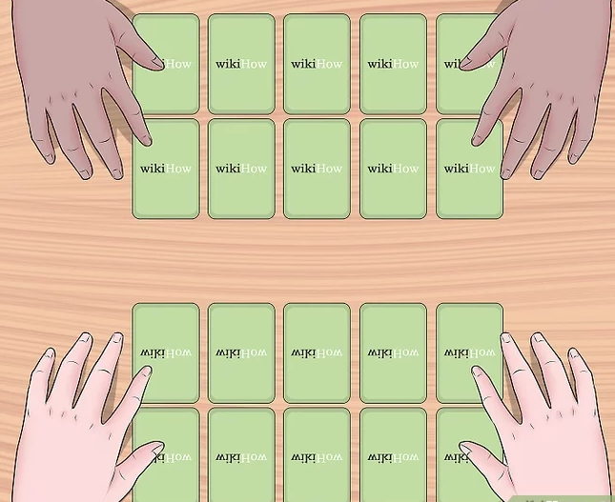 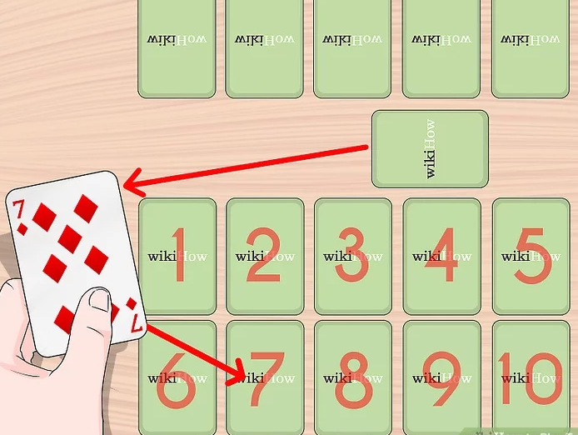 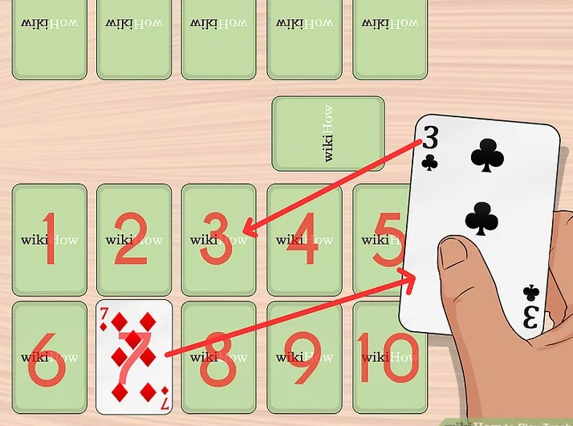

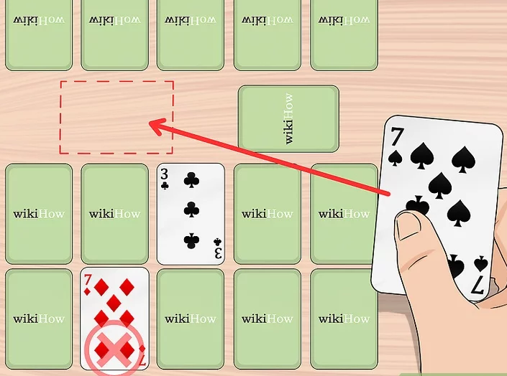 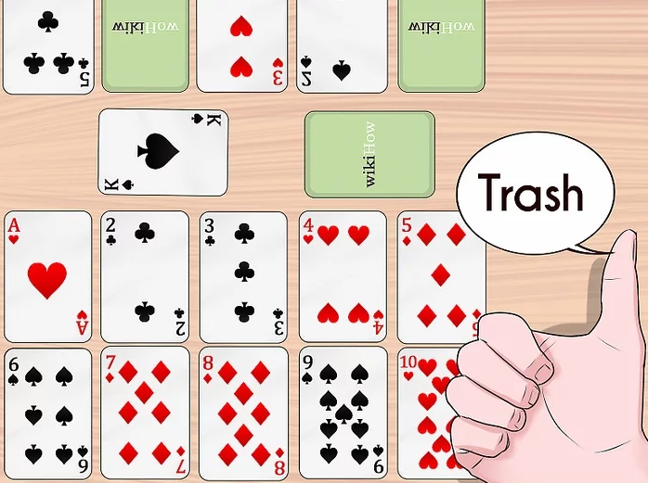

* Try one of these five [Thinking games,](https://www.whatdowedoallday.com/2012/07/five-thinking-games-for-kids.html) which  are a fun way to pass the time and can be played instantly.
* Play [Mad Libs](http://www.amazon.com/gp/product/0843126981/ref=as_li_tl?ie=UTF8&camp=1789&creative=390957&creativeASIN=0843126981&linkCode=as2&tag=wdwdad-20&linkId=23E3FKHBFEXO6KCP)! My kids and I like to play this at the dinner table.
* Start a drawing game. One person starts by drawing a shape on a piece of paper and passing it to the next player, who adds to it. Keeping passing around the drawing until everyone has a turn (*if it’s a large group*), or for a predetermined number of times (*if it’s a small group*). This can be played with as many players as you wish.
* Play hide and seek. It’s not just for kids! Kids love to find the grown-ups!
* Try a pencil and paper game, like [Dots and Boxes](https://www.whatdowedoallday.com/2015/01/dots-boxes-game-indoor-game-can-play-instantly.html). (<— There’s a video with instructions in that post.)
* Play hot potato.
* Play an old school game of  [spoons](http://www.coffeecupsandcrayons.com/family-card-games-how-to-play-spoons/" \t "_blank)!
* Play Simon Says.
* Play a guessing game: put an assortment of items on a tray, everyone tries to memorize the items. Everyone closes their eyes then one person removes a few items and players try to guess what was removed. I even have tons more[memory games ideas](https://www.whatdowedoallday.com/2016/08/memory-games-for-kids.html).
* Everyone has a deck of cards. Try one of these [40 games to play with cards](http://www.deliacreates.com/40-card-games-kids/)!

SPIT!

##### Requires

A standard deck of cards (no Jokers)  
2 players

##### Game play

Deal the cards evenly between the players (26 each), facedown. A player may not look at his cards. Each player creates five piles of cards, with 1, 2, 3, 4, and 5 cards in each stack, respectively. Turn the top card of each pile face-up. The leftover 11 cards become the stockpile and are placed in front of the player.

When both players are ready, they simultaneously yell, “Spit,” and flip over a card from their stockpile. These two face-up cards are placed side-by-side at the center of the table. They are now the first cards of the “spit piles.”

The players start moving very quickly at this point. It is important to remember that players can only use one hand to move cards around during the game, and that they can only move one card at a time. Players try to move the face-up cards from their five piles onto the spit piles (both players can use both spit piles). To play a card from one of the five piles onto the spit piles, the card must be next in sequence (either one rank higher or one rank lower; suits don’t matter) than the card on the top of a spit pile. The spit piles change rapidly as each player slaps a new card on them.

##### Objective

The first player to get rid of all the cards from their five piles wins. If both players cannot make a legal play on a spit pile, then they yell, “Spit!” again, and flip new stock cards on the spit piles simultaneously. The action continues like this until someone runs out of cards.

ACTIVE GAMES

## Four Corners

Sit down in the center of the room and assign a number to each corner of the room. The person in the middle is blindfolded while everyone on the outside chooses a corner of the room to stand in as quietly as they can. The person in the middle then chooses a corner. Everyone in that corner is out. The game continues until there is one person left and he/she is the winner.

## Waste Paper Shootout

This is like the 3 point competition during NBA All-Star Weekend. Take two buckets, waste paper baskets, or large bowls and put them in front of your kids at a certain distance. Each kid has their own designated bucket. Give them a stack of paper. They have to take the paper, crumple it, and shoot as many sheets as they can in one minute. Play music to make it more fun.

## Learn a Dance

Go on Youtube and find a popular dance. Learn it as a family. Don’t worry if you aren’t a good dancer, that isn’t the point. Have your kids help you and laugh together. If you are a good dancer help teach them.

2. DICEY

In this game, players will attempt to stack six dice on a popsicle stick while holding it in their mouth. The full stack must stay up for at least three seconds. Sounds fairly easy, right? It’s harder than you think! Keep track of how high everyone gets before their dice fall, just in case no one can complete the challenge in a minute.

3. KEEP IT UP

Players must use only their breath to keep two feathers in the air for a full minute…or for as long as they can. You can also use a straw to concentrate the air or simplify things by using only one feather for younger children.

### 8. Paper ball RACE

Set up a start and finish line for your race course, then line up 5 small balls of paper for each player at the start. They must use their breath to blow their paper balls across the finish line. The first one finished or the one with the most over the line after a minute is up is the winner!

LAND AIR SEA

Separate land and sea – you can use tape, a small carpet, a line of shoes. When the leader yells “Land” all players must run to the land. When the leader yells “Sea”, all players must run to the sea. When the leader yells “Air”, all players must jump as high as they can. Play until tired ☺

SOCK HOCKEY

Rolled up socks and brooms.

FREEZE DANCE

Grab the radio and dance – freeze when the music stops. Get silly with your frozen positions!

**Drawing puzzle.** Go outside and draw something in nature on a large piece of paper.  Participants color and decorate, then cut paper into 12 puzzle pieces.  Swap puzzles and assemble.  The first person done wins.

**Kick the can.**  Fun to play at dusk.  Place a can in middle of the play area.  The person who is “it” counts while people hide.  When “it” finds and tags a player, that player gets stranded on “the island,” a designated area near the can.  Anyone who is not “it,” or anyone who has not been tagged, may sneak up and kick the can, thus rescuing the stranded person.  If “it” can get everyone on the island, a new person is designated as “it,” usually the person who has been on the island the longest.  Variations of this game exist.

**What’s the Word?** Choose a person to write out words on small pieces of paper and tape one to each participant’s head or back: snake, zebra, cake, rainbow, table, backpack, any noun – or make categories each round. For example, first round is an animal, second round is food, third round is a sport, etc..  Participants mingle around room and ask yes/no questions to figure out the word.  First person to figure out his/her word wins.

Simon Says – The leader asks the other players to follow a simple command like “touch your nose.” However, the leader must say “Simon Says” before each command IF player must follow the command. If the leader does not say “Simon Say,” the player should not follow the command. If the player follows a command that did not start with “Simon Says,” the player is out.

**Mirror, Mirror:** Stand face to face with another person, about a foot apart, and have them attempt to copy all your movements. Reach up and stretch to the sky. Do 10 jumping jacks. Run in place. Act like a monkey. Make it fun and you’ll both be working up a sweat in no time. Then switch roles.

ABC HUNT – Write the alphabet on a piece of paper. Give each player something to write with and set them free to explore! Each player will try to find something in the building